WEEK 2 TASK
DATA ACQUISITION AND MANAGEMENT PLANNING
Customer Churn Prediction Using Python and Machine Learning
Field | Details
Prepared By | Amrutha T
Role | Data Science Project Coordinator
Week | Week 2
Task Period | 25–31 August 2026
Overall Project Horizon | 5 weeks
Project Type | Educational / hypothetical data-science project using a public dataset
Primary Tools | Python, Pandas, NumPy, Matplotlib, Seaborn, Scikit-learn, Jupyter/Google Colab, Git/GitHub

Submission focus
This version is designed to address the Week 1 evaluator feedback by adding concrete dataset facts, measurable acceptance criteria, worked Python examples, explicit evidence tables, visual data-pipeline diagrams, and a fully aligned five-week timeline.

1. Executive Summary

Week 2 converts the Week 1 project strategy into a concrete, reproducible plan for acquiring, managing, cleaning and preparing data for later analysis. The selected dataset is the IBM Telco Customer Churn sample dataset. The report records measurable dataset facts, defines all 21 fields, specifies an acquisition procedure, sets data-quality gates, provides Python examples, and defines the evidence that must be retained before the processed dataset is released for Week 3 exploratory data analysis.
The report deliberately distinguishes verified dataset facts from planned processing steps. The figures in the dataset profile are treated as source-supported facts; planned train/test splitting and preprocessing are not presented as completed experiments. No model-performance results are fabricated.

Response to Week 1 evaluator feedback
The previous feedback identified three issues: insufficient specific data, insufficient worked examples/concrete numbers, and a timeline that was not explicit enough for a five-week horizon. This report addresses each issue directly through quantitative dataset profiling, field-level rules, Python examples, quality-gate evidence, two pipeline diagrams, and a dated Week 1–5 schedule.

Week 2 Requirement-to-Evidence Map
Requirement | Evidence | Concrete evidence
Public data sources | Section 4 | Dataset name, source rationale, source documentation
Data acquisition strategy | Section 5 | 10-step acquisition procedure + evidence retained
Ethical/legal considerations | Section 6 | Responsible-use rules and boundaries
Cleaning/preprocessing | Sections 7–8 | Field-level rules, validation and transformations
Python integration | Section 9 | Worked Pandas + Scikit-learn examples
Visual pipeline | Section 10 | Acquisition-to-analysis flowchart
Quality control | Section 11 | 8 quality gates + pass/fail actions
Data management | Section 12 | Folder structure, naming, versioning
Risk management | Section 13 | Risk, impact, mitigation, trigger/evidence
Timeline | Section 14 | Week 2 daily schedule + complete five week horizon

Project Context and Week 2 Objective
The project is an educational/hypothetical customer churn classification project. The Week 2 objective is not to claim a finished predictive model; it is to establish a trustworthy data foundation that can be used for Week 3 EDA and later model development.
Week | Dates | Primary purpose | Evidence
1 | 18–24 Aug 2026 | Business understanding, scope, planning and risks | Week 1 planning report
2 | 25–31 Aug 2026 | Acquisition, profiling,  cleaning, preprocessing and management | This report + source metadata + profile
3 | 1–7 Sep 2026 | EDA, distributions, missingness analysis and insights | Notebook + charts + findings
4 | 8–14 Sep 2026 | Feature preparation, baseline models and comparison | Model notebook + comparison
5 | 15–21 Sep 2026 | Evaluation, error analysis, recommendations and final documentation | Final report + presentation
End | 22 Sep 2026 | Submission/administration checks | Submission confirmation

Selected Public Dataset and Quantitative Profile

Source selection
Primary source: IBM Telco Customer Churn sample data. IBM documentation describes a telecommunications churn example using customer information to predict customer loss. The dataset is appropriate for this educational project because the target is binary and the data contains both categorical and numerical variables.
External source verification: IBM documentation and IBM sample-data material are used for source traceability. The source material describes the dataset as fictional/sample data.

Verified quantitative profile
Attribute | Verified detail | Planning implication
Dataset | Telco Customer Churn | Suitable for binary churn classification
Records | 7,043 | Large enough for planned profiling and train/test preparation
Fields | 21 | Schema must contain the expected 21 fields
Target | Churn (Yes / No) | Validate labels before mapping to 1/0
Complete records | 7,032 | Incomplete records must be quantified and handled
Churn = Yes | 1,869 (26.6%) among complete records | Minority class; use stratification
Churn = No | 5,163 (73.4%) among complete records | Majority class; avoid accuracy-only interpretation later
Known missingness | Associated with TotalCharges | Convert to numeric and inspect resulting missing values

Concrete evidence rule
These numbers are reported as dataset/source facts from the supplied Week 2 material. They are not presented as results produced by a new model run in this report.

Data dictionary – all 21 fields
Field | Type | Role | Planned handling
CustomerID | Identifier | Traceability only | Retain for audit; exclude from predictors
gender | Categorical | Demographic | Normalize; one-hot encode if retained
SeniorCitizen | Binary numeric | Demographic | Retain 0/1; range check
Partner | Categorical | Household context | Normalize; one-hot encode
Dependents | Categorical | Household context | Normalize; one-hot encode
tenure | Numeric | Customer duration | Convert numeric; check >= 0
Phone Service | Categorical | Service | Normalize; one-hot encode
MultipleLines | Categorical | Service | Normalize; one-hot encode
InternetService | Categorical | Service | Normalize; one-hot encode
OnlineSecurity | Categorical | Service | Normalize; one-hot encode
OnlineBackup | Categorical | Service | Normalize; one-hot encode
DeviceProtection | Categorical | Service | Normalize; one-hot encode
TechSupport | Categorical | Service | Normalize; one-hot encode
Streaming TV | Categorical | Service | Normalize; one-hot encode
Streaming Movies | Categorical | Service | Normalize; one-hot encode
Contract | Categorical | Contract | Normalize; one-hot encode
Paperless Billing | Categorical | Billing | Normalize; one-hot encode
Payment Method | Categorical | Billing | Normalize; one-hot encode
MonthlyCharges | Numeric | Billing | Convert numeric; check >= 0
TotalCharges | Numeric after conversion | Billing | Strip spaces; coerce numeric; document missing values
Churn | Binary target | Prediction target | Accept Yes/No; map to 1/0 after validation

Step-by-Step Data Acquisition Strategy
Step | Action | Method | Evidence
1 | Record source metadata | Dataset name, source family, access date, description and expected schema | Source metadata sheet
2 | Acquire raw file | Download the public educational dataset into data/raw/ | Raw file
3 | Preserve original | Do not modify or overwrite the raw source | Read-only/raw-data rule
4 | Record file identity | Record filename, size and, where available, checksum/hash | File identity log
5 | Verify readability | Load with Pandas and confirm CSV parsing | Load log
6 | Verify schema | Compare actual columns with expected 21-field schema | Schema checklist
7 | Profile before cleaning | Record shape, dtypes, missingness, duplicates and category values | Profile table
8 | Create interim copy | Apply cleaning only to a versioned copy | Interim dataset
9 | Save processing evidence | Retain notebook/script, decision log and validation outputs | Evidence folder
10 | Release analysis-ready data | Release only after all quality gates pass | Processed dataset + QA signoff

Acquisition decision rules
- If the file cannot be read, stop the pipeline and reacquire the source.
- If the schema differs from the expected 21 fields, investigate before cleaning.
- If a checksum is available and changes unexpectedly, treat the source as a new version and document it.
- Never clean or overwrite the raw source file.
- Do not release the processed dataset until all quality gates pass.

Ethical, Legal and Responsible Data Handling
Principle | Rule | Evidence
Public/sample data only | Use the public educational dataset; private customer records are out of scope. | No confidential customer collection.
Traceability | Record source and attribution. | Source metadata and references retained.
Privacy | Treat the dataset as fictional/sample data and do not publish private information. | No personal-data expansion.
Responsible inference | Do not infer sensitive characteristics beyond what the dataset supports. | Avoid unsupported conclusions.
Evaluation integrity | Do not manipulate evaluation methods to obtain preferred results. | Document assumptions and limitations.
Reproducibility | Use version control and reproducible code. | Git + requirements + notebook/script.

Data Quality and Cleaning Workflow
Cleaning is treated as a controlled sequence. Each material decision is recorded in a cleaning decision log so that another reviewer can understand what changed, why it changed, and what evidence supports the decision.
Check | Why | Rule/action | Evidence
File readability | Prevents corrupted input | Open CSV; confirm parsing | Load log
Shape | Confirms expected dataset | Record rows/columns before cleaning | Profile table
Column names | Prevents downstream errors | Compare against expected 21field schema | Schema checklist
Duplicate rows | Avoids duplicate records | Count exact duplicates; investigate before removal | Duplicate count + decision
Customer ID duplicates | Identity/traceability issue | Check uniqueness; do not silently drop | ID uniqueness check
Missing values | Affects analysis/modeling | Profile by field; apply documented rule | Missingness table
TotalCharges type | Blank strings may prevent numeric analysis | Strip spaces; coerce numeric; inspect resulting NaNs | Conversion log
Whitespace/case | Creates false categories | Strip and normalize text where appropriate | Unique-value comparison
Numeric ranges | Detects invalid values | tenure >= 0; Monthly Charges >= 0; Total Charges >= 0 when present | Range report
Target values | Protects label integrity | Only Yes/No accepted; map to 1/0 | Target validation
Leakage | Prevents optimistic results | Exclude IDs/target-derived fields; fit learned transforms  on training data only | Feature audit

Worked example: Total Charges conversion
The supplied source material identifies blank-string behavior in Total Charges. The plan therefore converts the field explicitly and counts the values that become missing. A blank is not silently treated as zero.
import pandas as pd
df = pd.read_csv("data/raw/telco_customer_churn.csv") df["TotalCharges"] = pd.to_numeric( df["TotalCharges"].astype(str).str.strip(), errors="coerce"
)
Missing totalcharges = df["Total Charges"].isna().sum() print("TotalCharges missing after conversion:", missing_totalcharges)

Expected evidence to retain
The executed notebook should show the actual missing-value count after conversion and record the decision taken

Transformation and Preprocessing Plan
Variable/step | Transformation | Reason | Validation
Churn | Yes/No → 1/0 | Machine-learning target representation | Only two valid labels
TotalCharges | String → numeric | Enable numeric analysis/modeling | Inspect newly introduced NaNs
Categorical features | One-hot encoding | Convert categories to numeric indicators | Check encoded columns + unknown categories
Numeric features | Retain numeric; scale only when required | Avoid unnecessary transformation | Compare summary/range before/after
customerID | Exclude from predictors | Identifier has no predictive meaning | Feature-list audit
Train/test | 80/20 stratified split; random_state=42 | Preserve minority proportion + reproducibility | Check class distribution

Why the order matters
- Profile first so cleaning decisions are based on observed data quality.
- Separate the target before modeling and exclude customerID from predictors.
- Fit learned preprocessing only on training data.
- Keep the test set unseen until final evaluation.
- Use a fixed random_state for reproducibility.

Worked example: one-hot encoding
from sklearn.preprocessing import OneHotEncoder
encoder = OneHotEncoder( handle_unknown="ignore",
sparse_output=False
)
X_cat_encoded = encoder.fit_transform(X_cat_train)
The encoder is planned to be fitted on training categorical data and reused for later data. This prevents the test set from influencing the learned category representation. Scikit-learn documents OneHotEncoder as a transformer for converting categorical features into one-hot numeric representations.

Worked example: stratified train/test split
from sklearn.model_selection import train_test_split
X = df.drop(columns=["Churn"]) y = df["Churn"].map({"No": 0, "Yes": 1})
X_train, X_test, y_train, y_test = train_test_split(
X, y, test_size=0.20, stratify=y,
random_state=42
)
This is a planned procedure. It is not an achieved model result. Actual split counts and later model metrics will be reported only after execution in Weeks 4–5.

Important distinction

Data Pipeline Diagram and Annotation
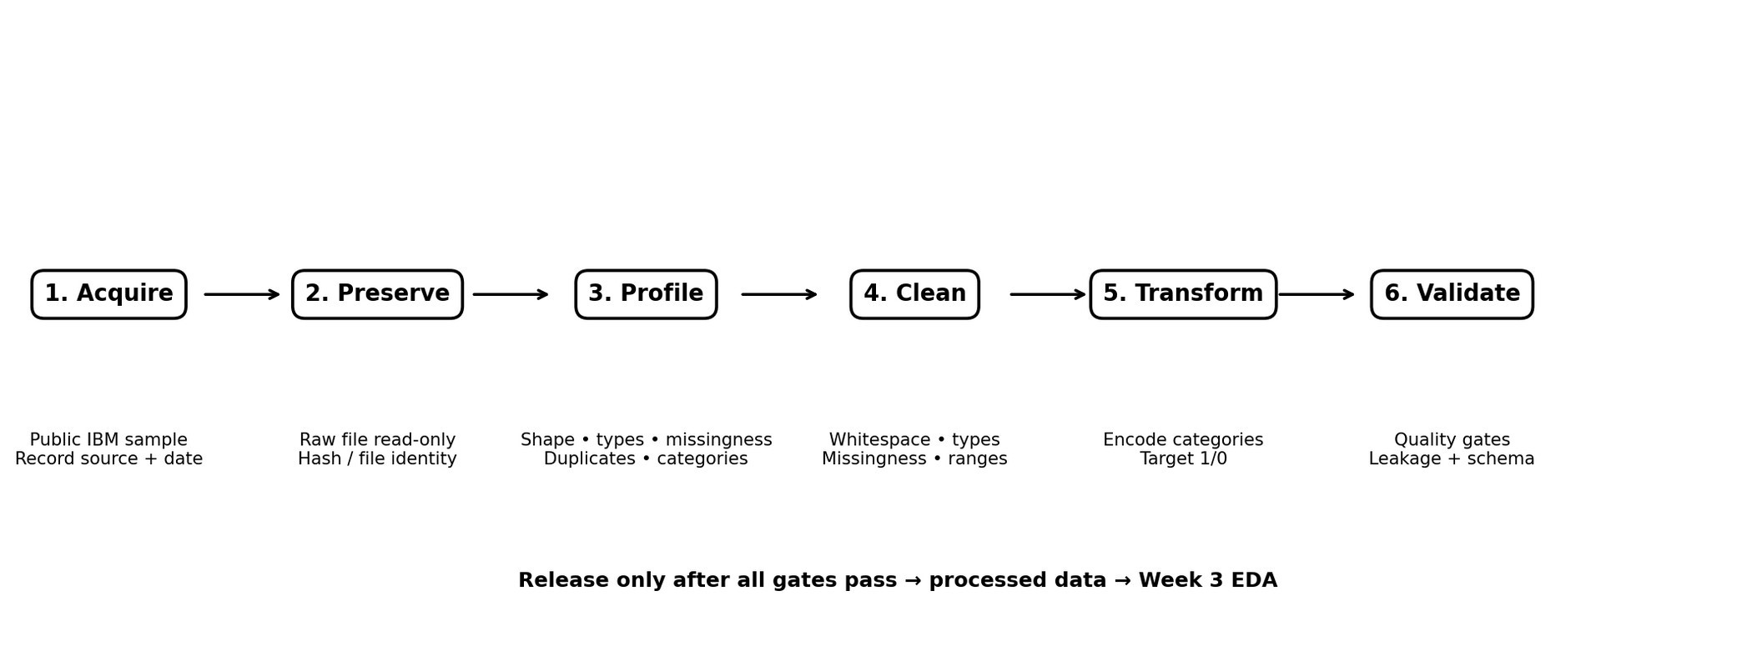
Figure 1. Planned Week 2 data pipeline. The processed dataset is released only after the validation gates pass; it then becomes the input for Week 3 EDA.
Stage | Input | Output | Control
Acquire | Public source | Raw file | Source metadata
Preserve | Raw file | Read-only copy | Checksum/file identity
Profile | Raw file | Quality profile | Shape, types, missingness, duplicates
Clean | Interim copy | Cleaned data | Decision log
Transform | Cleaned data | Model-ready features | Encoding/type checks
Validate | Transformed data | Approved processed data | 8 quality gates

Reproducible Python Workflow
import pandas as pd import numpy as np
RAW_PATH = "data/raw/telco_customer_churn.csv" df = pd.read_csv(RAW_PATH)
print("Shape:", df.shape) print("\nDtypes:") print(df.dtypes) print("\nMissing values:")
print(df.isna().sum().sort_values(ascending=False)) print("\nDuplicates:", df.duplicated().sum()) print("\nTarget counts:") print(df["Churn"].value_counts(dropna=False))
This script is a reproducible acquisition/profiling skeleton. It is intended to generate evidence such as shape, data types, missingness, duplicate count and target counts when executed. The report does not present unexecuted output as if it were executed evidence.

Example evidence table to complete during execution
Check | Command/output | Acceptance rule | Status
Shape | df.shape | Expected 7,043 rows and 21 | To verify in execution
 |  | fields based on source profile
Missingness | df.isna().sum() | All missing values quantified | To verify in execution
Duplicates | df.duplicated().sum() | Investigate any exact duplicates | To verify in execution
Target counts | df['Churn'].value_counts() | Only Yes/No accepted | To verify in execution
Schema | df.columns | Expected 21 fields | To verify in execution

Validation, Quality Gates and Leakage Controls
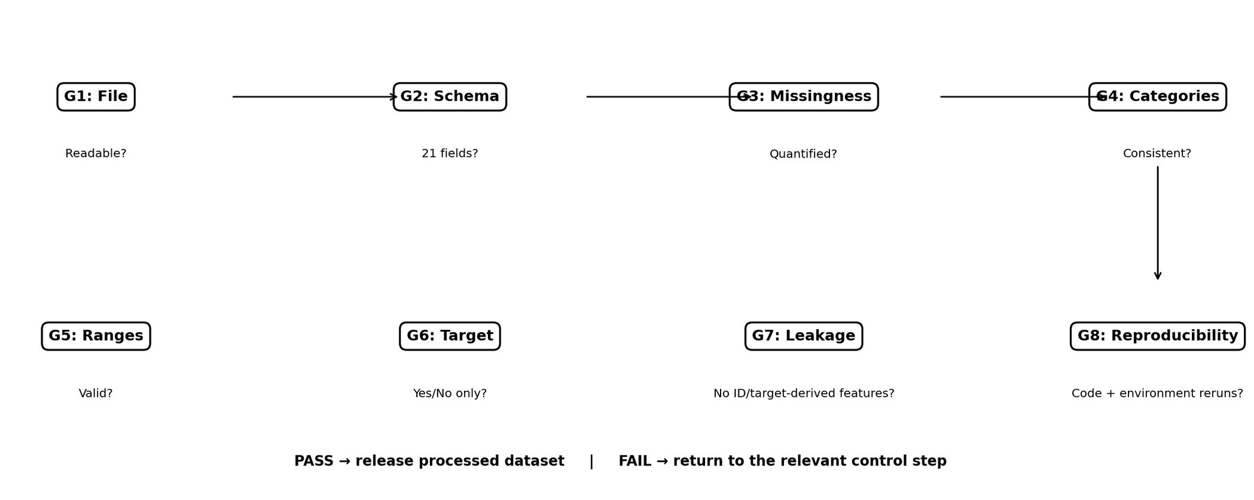
Figure 2. Quality-control gates. A failed gate sends the workflow back to the relevant correction step.
Gate | Pass condition | Failure action
G1: File | File opens and schema is readable | Stop pipeline; reacquire source
G2: Schema | Expected fields present; unexpected fields logged | Investigate before cleaning
G3: Missingness | Missing values quantified and handled by documented rules | Return to cleaning log
G4: Categories | No unexplained category variants remain | Normalize/investigate
G5: Numeric ranges | No unexplained invalid/negative values in constrained fields | Investigate records
G6: Target | Only valid Churn labels remain | Stop and correct label issue
G7: Leakage | No target-derived or identifier predictor is used | Remove feature + review pipeline
G8: Reproducibility | Notebook/script reruns with documented environment and fixed seed | Fix dependencies/code

Leakage checklist
- customerID is excluded from predictors.
- Churn is separated before feature transformations.
- Target-derived fields are prohibited.
- Learned encoders/scalers are fitted on training data only.
- The test set remains untouched during model selection/tuning.
- Future feature engineering is checked for post-outcome information.

Data Management, Folder Structure and Versioning
Customer-Churn-Prediction/
├── data/
│ ├── raw/ # original downloaded data; do not edit
│ ├── interim/ # temporary cleaned/intermediate data
│ └── processed/ # analysis-ready dataset
├── notebooks/ # profiling and preprocessing notebooks
├── src/ # reusable Python scripts
├── reports/ # Week 1, Week 2 and later reports
├── figures/ # charts and diagrams
├── requirements.txt # Python environment specification
└── README.md # project documentation
Management rule | Implementation | Evidence
Raw-data protection | Never overwrite raw file | Raw folder + checksum
Naming | lowercase, descriptive, underscores | Example: telco_churn_clean_v01.csv
Versioning | Git commits for meaningful changes | Commit history
Reproducibility | requirements.txt + notebook/script | Fresh-run test
Data sharing | Do not commit raw data unless redistribution rights permit | Repository review

Data Acquisition Risk Management
Risk | Probability | Impact | Mitigation | Trigger/evidence
Source/version changes | Medium | Medium | Record source, access date and hash | Schema/hash differs
Incomplete download | Low | High | Check file size, readability and row/column counts | Unexpected shape
Missing values | High | Medium | Profile before cleaning; field-specific rules | NA count > 0
Inconsistent categories | Medium | Medium | Normalize whitespace/case; inspect unique values | Unexpected category
Data leakage | Medium | High | Feature audit; isolate target; training-only fitting | Target-derived field
Raw-data overwrite | Low | High | Read-only raw folder + versioned outputs | Raw checksum changes
Reproducibility failure | Medium | Medium | Requirements + notebook/script + Git | Fresh run fails
Privacy/unauthorized use | Low | High | Public educational data only | Unexpected personal data

Acceptance Criteria and Evidence Checklist
Deliverable | Acceptance criterion | Evidence
Source metadata | Source, version/access date and attribution documented | Metadata record
Dataset profile | Rows, columns, target, class distribution and missingness documented | Profile table
Data dictionary | All 21 fields have type, role and handling rule | Section 4.3
Acquisition | Step-by-step process documented | Section 5
Cleaning | Missingness, duplicates, types, categories and ranges covered | Section 7
Transformation | Encoding, target and numeric handling explained | Section 8
Python | Reproducible examples included | Section 10
Visuals | Pipeline and QC flowcharts included | Figures 1–2
Quality gates | Pass/fail actions defined | Section 11
Management | Folder structure, naming and versioning defined | Section 12
Ethics | Responsible-use boundaries documented | Section 6
Risks | Triggers and mitigations defined | Section 13
Timeline | Week 2 daily schedule + full five-week horizon | Section 15
No fabricated metrics | Unexecuted procedures clearly labeled as planned | Throughout report

Detailed Week 2 Schedule
Date | Activity | Concrete output | Completion check
25 Aug 2026 | Confirm dataset source/version and acquisition metadata | Source record + raw file | Source and file recorded
26 Aug 2026 | Profile schema and data quality | Shape, dtypes, missingness and unique-value report | Profile saved
27 Aug 2026 | Define cleaning rules | Cleaning decision log + data dictionary | Rules reviewed
28 Aug 2026 | Define transformations | Encoding, type and target strategy + code | Transformation plan complete
29 Aug 2026 | Build pipeline diagram and quality gates | Figures + validation checklist | Visuals/checklist complete
30 Aug 2026 | Review ethics, management and reproducibility | Risk/ethics/versioning review | Checklist complete
31 Aug 2026 | Finalize report and submission package | Final Week 2 report | Final QA complete

Explicit five-week project horizon
Week | Dates | Activities | Primary deliverable | Evidence
Week 1 | 18–24 Aug 2026 | Business understanding, problem, scope, objectives,  methodology, risks and milestones | Project Planning and Strategy report | Approved Week 1 report
Week 2 | 25–31 Aug 2026 | Dataset selection, acquisition, profiling, data dictionary, cleaning,  preprocessing, quality gates and management | Data Acquisition and Management Planning report | Source metadata + profile + processing plan
Week 3 | 1–7 Sep 2026 | EDA,  missingness/distributio n analysis, churn patterns, visualizations and initial insights | EDA report + visualization set | Notebook + charts + findings
Week 4 | 8–14 Sep 2026 | Feature preparation, train/test pipeline, baseline model, model comparison and | Model Development report | Notebook + model comparison
 |  | controlled tuning
Week 5 | 15–21 Sep 2026 | Final evaluation, metric interpretation, error analysis, recommendations, limitations and final documentation | Final Evaluation and Recommendations report | Evaluation results + final  report/presentation

Schedule-control rule
Each week has one primary deliverable and corresponding evidence. If a task is delayed, the deviation is recorded in the project monitoring log rather than silently compressing the five-week horizon.

References and Traceability
Source | Use in this report | Reference
IBM | Predict telecommunications churn — IBM documentation. Used for dataset context and churn workflow. | https://www.ibm.com/docs/en/ws-and-kc?  topic=tutorials-predicttelecommunications-churn
IBM Community | Telco customer churn sample  information. Used for source/data-context traceability. | https://community.ibm.com/community/ user/blogs/steven-macko/2019/07/11/telcocustomer-churn-1113
Pandas | pandas.read_csv documentation. Used for CSV acquisition/profiling procedure. | https://pandas.pydata.org/pandas-docs/ stable/reference/api/ pandas.read_csv.html
Scikit-learn | OneHotEncoder documentation. Used for categorical preprocessing plan. | https://scikit-learn.org/stable/modules/ generated/  sklearn.preprocessing.OneHotEncoder.ht ml
Note: The report uses source-supported dataset facts and planned procedures separately. Model accuracy, precision, recall and F1-score are intentionally excluded from Week 2 because model training and evaluation belong to later project stages.

Conclusion
This Week 2 plan establishes a controlled and reproducible data foundation for the customer churn project. It moves beyond high-level planning by documenting a specific public dataset, quantitative dataset facts, a complete 21-field data dictionary, acquisition steps, ethical boundaries, cleaning rules, transformation logic, Python examples, quality gates, leakage controls, versioning practices, risk triggers and an explicit five-week project horizon.
The plan is designed to be evidence-oriented: every major activity has a measurable check, an expected output, or a decision rule. This directly addresses the Week 1 feedback requesting specific data, worked examples/concrete numbers, and clearer alignment to the five-week project horizon.

Final Submission Checklist
- DOCX opens correctly and contains the complete Week 2 task.
- Specific public dataset, quantitative profile and 21-field dictionary are included.
- Acquisition, cleaning, transformation and validation plans are traceable.
- Two visual pipeline/quality-control diagrams are included.
- Python examples demonstrate acquisition, profiling, numeric conversion, encoding and train/test splitting.
- Verified dataset facts are separated from planned/unexecuted procedures.
- Five-week timeline and Week 2 daily schedule are included.
- Ethics, risks, data management and versioning are documented.
- References are traceable to IBM, Pandas and Scikit-learn documentation.
- No unsupported model-performance metrics are claimed.

